TECHNICAL ANALYSIS (SAS)
This analysis is made by SAS 9.4, which is a comprehensive statistical analysis software suite that provides tools for data management, data analysis, and data visualization. It is designed to help users quickly and easily access, analyze, and report on complex data sets.

Initial Operations

Load operations
In order to import the excel file (.xlsx) of the data collected from the survey into the SAS software, the following commands were typed:

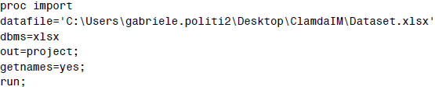
Before conducting the analysis of the data, a library has been created in order to permanently save the SAS inputs and the dataset, and a unique identifier has been entered in order to have greater control in subsequent analyses:
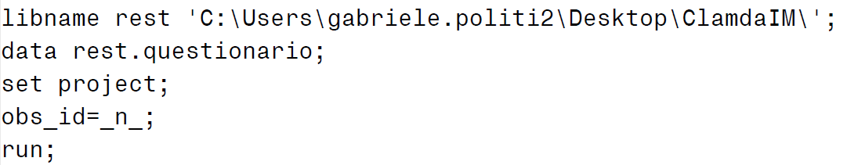
Consequently, the labeling of the following variables has been performed in order to rename the “contracted” variables (i.e., q1_9) and improve their interpretations, modifying the dataset “questionario” by stating the respective names:
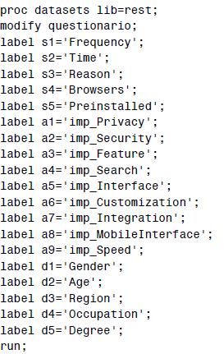

Frequency operations
It has been used ‘proc freq’ to display and analyze categorical data. Thanks to this command, it has been possible to display one-way, up until n-ways tables, to describe the sample and to analyze the demographic data:
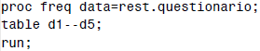
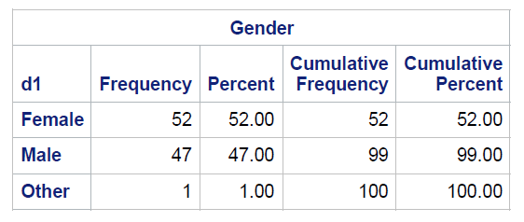
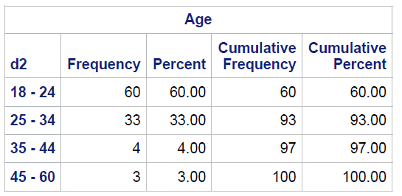

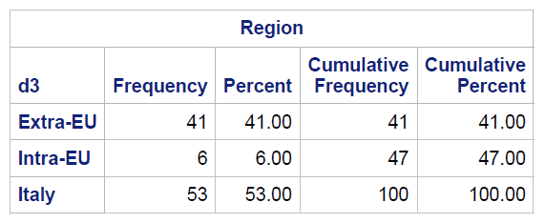

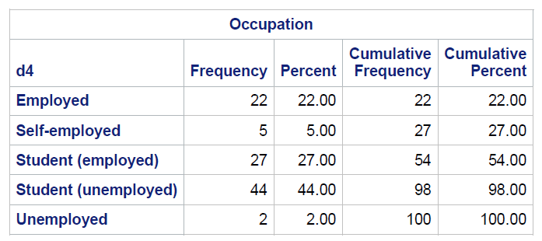

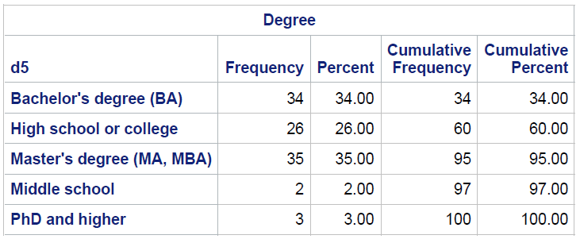

Mean operations
The means procedure is utilized to identify the impact of examined variables on the decision-making of the population sample. By using this command, variables can be listed, and the number of observations, mean, standard deviation, minimum, and maximum values can be obtained. This code, therefore, furnishes supplementary information that aids in the better comprehension of consumer satisfaction and choice:
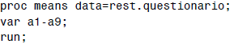
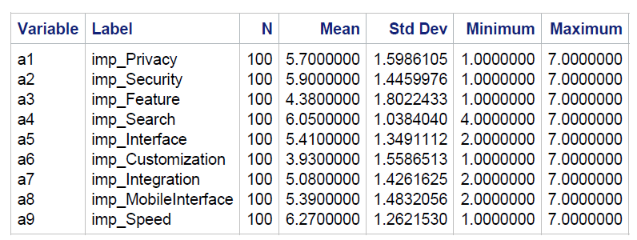
Principal Component Analysis (PCA)
Principal component analysis (PCA) is a technique used for reducing the dimensions of large datasets and minimizing the number of variables in smaller datasets. This statistical tool is primarily used to identify a smaller number of variables, called principal components, from a larger dataset. These new variables are calculated as linear combinations of the original variables and are referred to as factor scores. The
observations' values of the new variables are seen as projections into the new principal components. The eigenvalues related to a component are the sum of the component's squared factor scores.
PCA is primarily used to decrease the number of highly intercorrelated variables by projecting each data point into the first principal component. This results in low-dimensional data while still maintaining the data's variation and information accuracy. To achieve this, it is crucial to first center the variables to a zero mean. This simplifies the representations, as the center of the population's cloud coincides with the origin of the axes in the subspace.

To perform principal component analysis, the proc princomp command is used to summarize data and identify linear relationships.
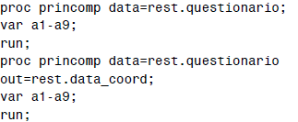
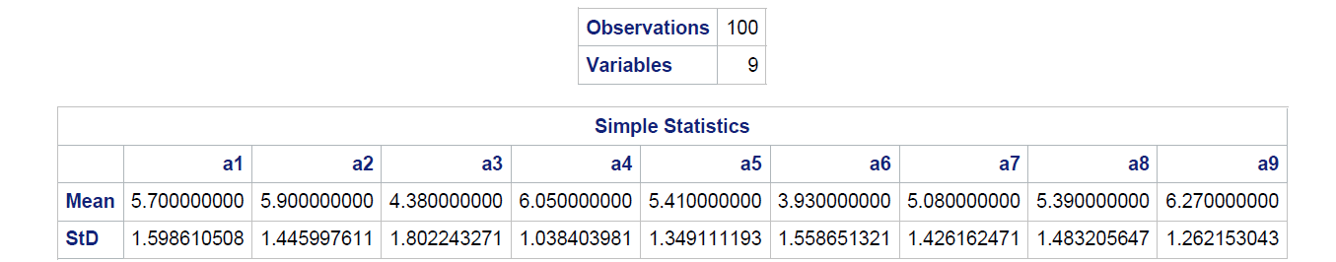

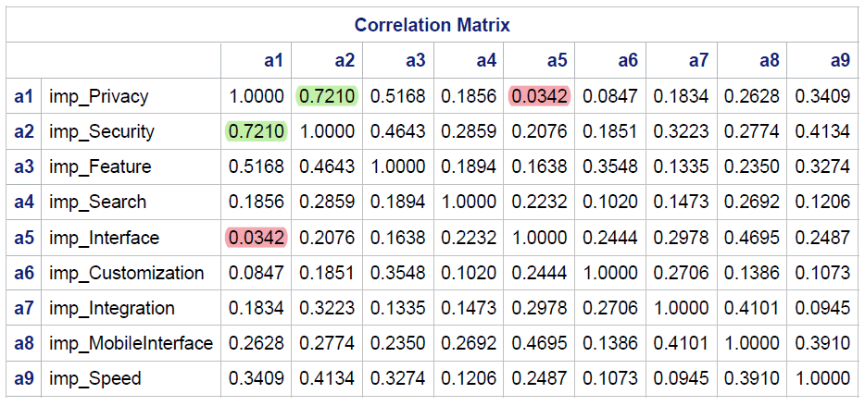
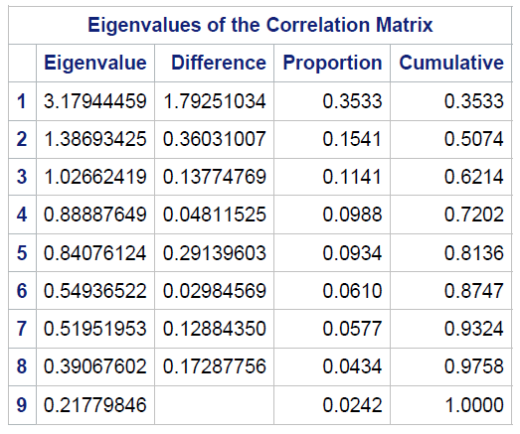

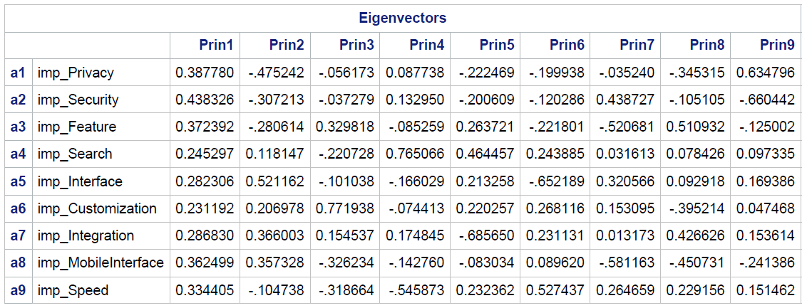

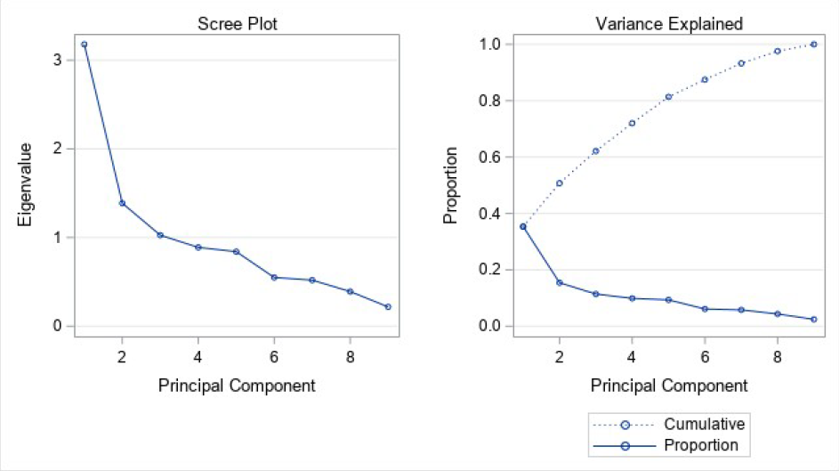

Size effect elimination
data rest.data_adj; set rest.questionario;
avg_i=mean(of a1-a9);
min_i=min(of a1-a9);
max_i=max(of a1-a9);
array a a1-a9;
array b new1-new9;
do over b;
b=.;
if a>avg_i then b=(a-avg_i)/(max_i-avg_i);
if a<avg_i then b=(a-avg_i)/(avg_i-min_i);
if a=avg_i then b=0;
if a=. then b=0;
end;

After calculating the average, the minimum and the maximum of each of the variables, they were transformed into new ones (i.e., “new1-new8”), using the “if” statement in order to set the conditions to restrict our scale and eliminate the biases. After running this code, new names were given to the new variables, by relabelling them:

label new1='privacy';
label new2='security';
label new3='feature';
label new4='search';
label new5='interface';
label new6='customization';
label new7='integration';
label new8='mobileinterface';
label new9='speed';
run;

FINAL PCA
At the end of this process, the Principal Component Analysis Procedure was run again on the new unbiased variables:

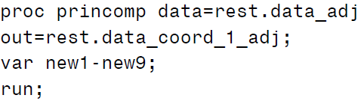
Removing the biases, we obtain a new correlation matrix, new eigenvalues and new eigenvectors:

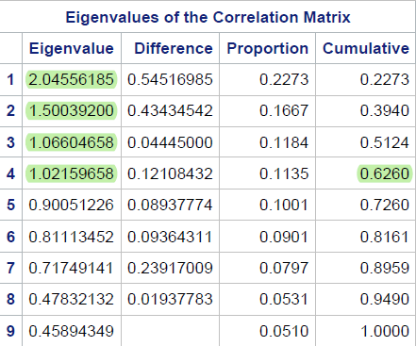

This new Eigenvalues table differs from the previous one because in this one we have that the first four variables have an eigenvalue greater than 1, and cumulatively explain almost 62,6% of the total variability. Hence, our previous idea is now supported by the data. Looking at the Eigenvectors table it is also evident that there are no more only positive correlations between the variables and the first principal component:
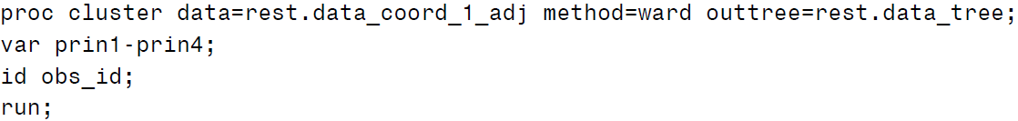

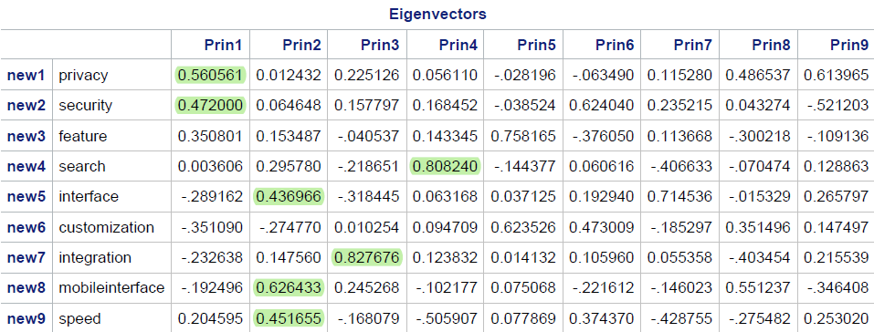

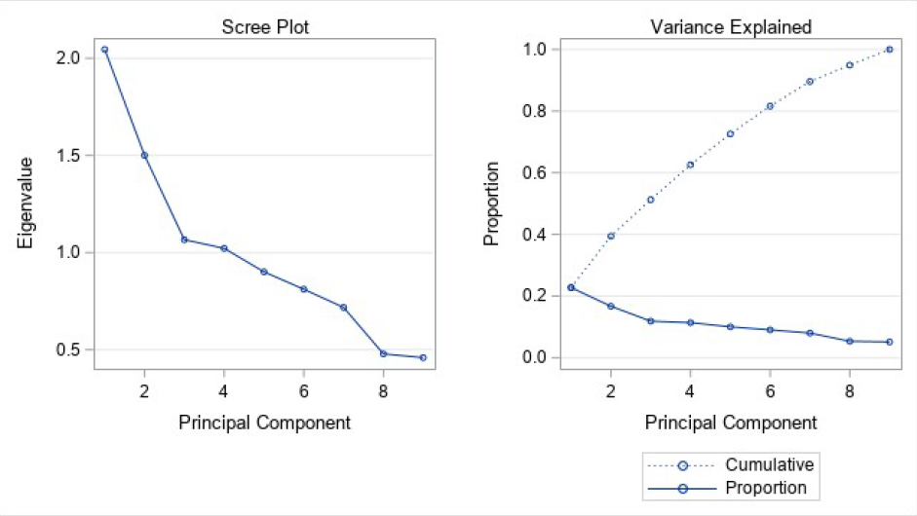

Now it can be performed a deeper analysis of the effects that the new variables exert on the first 4 principal components. The focus will be only on the strongest impacts that a certain variable exerts on the components. To increase the understandability, we provided a new name for each principal component:

Prin 1: privacy and security – Secrecy
Prin 2: interface, mobileinterface and speed – Facilities
Prin 3: integration – Compatibility
Prin 4: search – Explore

Based on Prin1, it is evident that the variables with the most substantial impact on this component are privacy (0.56) and security (0.47), while the other variables have either a negative impact or an insignificant impact. Consequently, Prin1 can be identified as Secrecy, because it describes the relation between the security and the privacy of a browser rather than other factors.
The variable "customization" has the most negative impact on Prin1 (-0.35). Hence, this variable is not essential to those respondents who prioritize his own information over other factors.
The analysis can be extended by examining the subsequent components. Prin2 is primarily influenced by the interface (0.436), mobile interface (0.626) and speed (0.451), which define the Facilities.
In contrast, Prin3 is strongly influenced by Integration (0.827), thereby characterizing a kind of Compatibility.
In conclusion, Prin4 is mainly affected by search (0.808), describing the capability to Explore of the browsers.

